NAME: Miftahul Huq

**Homework #1 Part B: Working with MySQL**

DUE:

Note: You must complete Homework #1 Part A before continuing.

Now let’s have some fun and start working with MySQL!

**MacOS** - To create a MySQL session via the Terminal window enter in the following: “/usr/local/mysql/bin/mysql -u root -p” (Figure 1). You will be prompted for your password, enter in the password that was set for root.

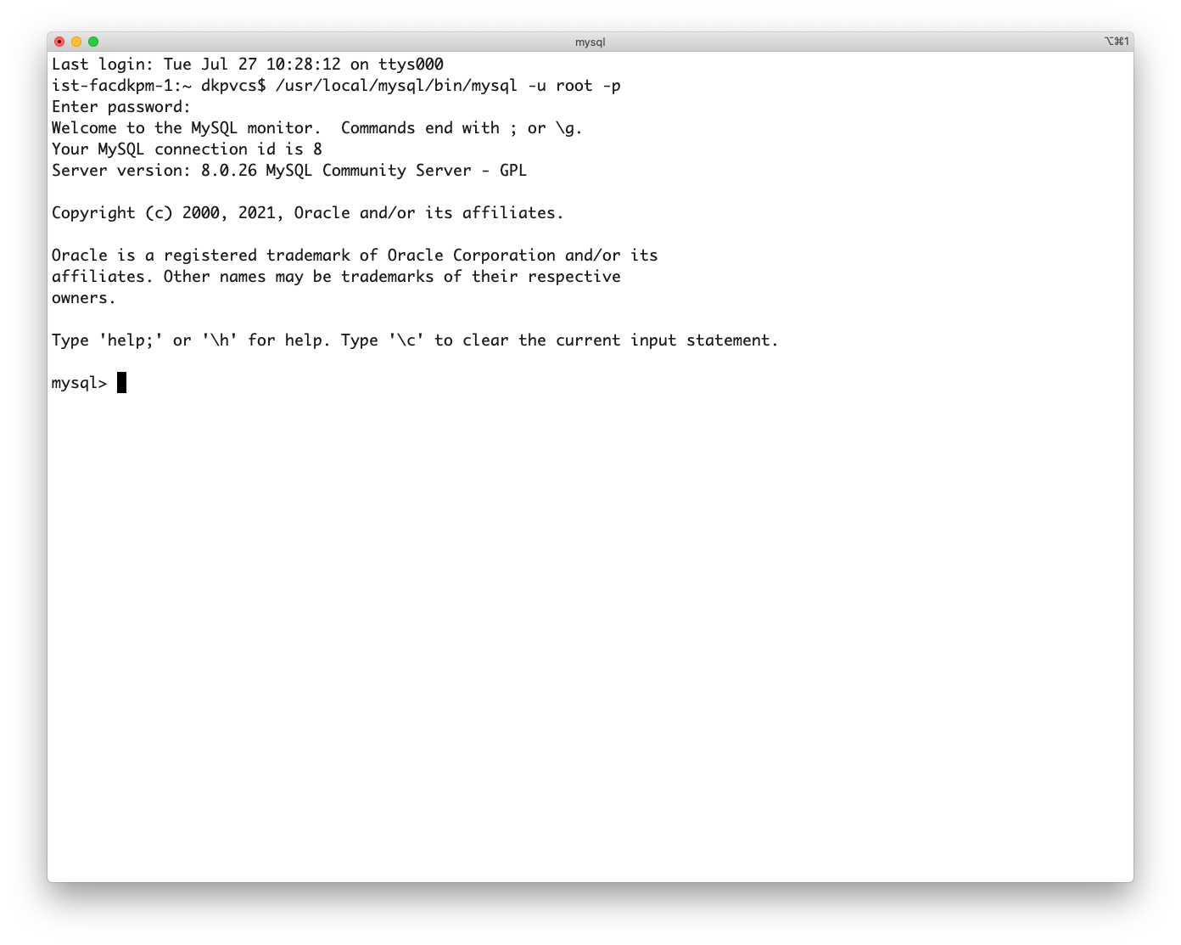

Figure 1. Starting a MySQL session in Terminal

**Windows**: To start MySQL do the following: Windows Menu -> MySQL -> MySQL 8.0 Command Line Client. Enter in the password that you set during the MySQL Server configuration. You should see a similar welcome message as in Figure 2.

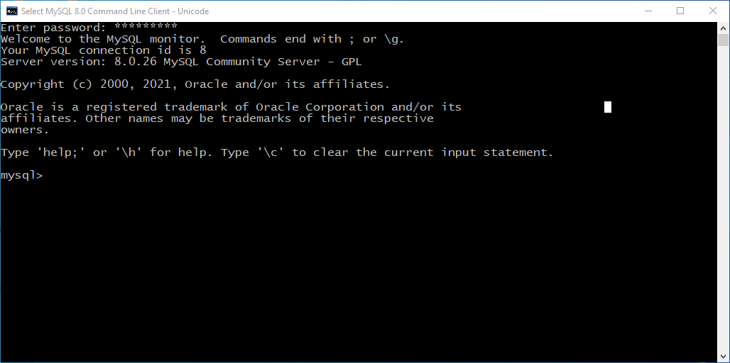

Figure 2. MySQL 8.0 Command Line Client.

For the following questions (1 and 2), type or copy/paste the requested data from the MySQL command-line interface.

1. Once you enter in your password, MySQL will give you a welcome message and inform you of the server version you are using. What version of MySQL Server are you running?

The MySQL Server version is 8.0.27

1. To see what databases are installed you can use ‘SHOW DATABASES;’ Please list the databases shown:

The table shows information_schema, mysql, performance_schema, and sys

It is also possible to query functions through a SELECT statement. Type in the following statements and report the results received, either by typing or copy/pasting from the MySQL Command Line Interface. If you copy/paste, using the Courier font, size 10 will properly align the output in this document. (Note: If you forget the ‘;’ at the end of a statement, in the MySQL Command Line Interface, you will be given a new line, just type in the ‘;’ and press ENTER.)

1. SELECT current_date;

**Results**: The result that is shown is a table with 2 rows. First row with the information that is the being selected, which is “current_date” as the header row, and the second with the current date of “2022-01-17”. The result also shows how many rows there are there after the header row, which is 1, and how much time it took to get the information and print it on the console, which is 0.00 sec.

1. SELECT current_time;

**Results**: The result that is shown is a table with 2 rows. First row with the information that is the being selected, which is “current_time” as the header row, and the second with the current time of “13:00:49”. The result also shows how many rows there are there after the header row, which is 1, and how much time it took to get the information and print it on the console, which is 0.00 sec.

1. SELECT current_timestamp;

**Results**: The result that is shown is a table with 2 rows. First row with the information that is the being selected, which is “current_timestamp” as the header row, and the second with the current timestamp of “2022-01-17 13:02:27”. The result also shows how many rows there are there after the header row, which is 1, and how much time it took to get the information and print it on the console, which is 0.00 sec.

1. SELECT current_user;

**Results**: The result that is shown is a table with 2 rows. First row with the information that is the being selected, which is “current_user” as the header row, and the second with the current user of “root@localhost”. The result also shows how many rows there are there after the header row, which is 1, and how much time it took to get the information and print it on the console, which is 0.00 sec.

Some function calls require parentheses to be included. Type in the following statements into the MySQL Command Line Interface and report (type or copy/paste) the results received.

1. SELECT now();

**Results**: The result that is shown is a table with 2 rows. First row with the information of the function that is being executed, which is “now()” as the header row, and the second with the current timestamp of “2022-01-17 13:12:27”. The result also shows how many rows there are there after the header row, which is 1, and how much time it took to get the information and print it on the console, which is 0.00 sec.

1. SELECT pi();

**Results**: The result that is shown is a table with 2 rows. First row with the information of the function that is being executed, which is “pi()” as the header row, and the second with the value of pi with 6 digits after the decimal of “3.141593”. The result also shows how many rows there are there after the header row, which is 1, and how much time it took to get the information and print it on the console, which is 0.00 sec.

1. SELECT user();

**Results**: The result that is shown is a table with 2 rows. First row with the information of the function that is being executed, which is “user()” as the header row, and the second with the current user of “root@localhost”. The result also shows how many rows there are there after the header row, which is 1, and how much time it took to get the information and print it on the console, which is 0.00 sec.

1. SELECT version();

**Results**: The result that is shown is a table with 2 rows. First row with the information of the function that is being executed, which is “version()” as the header row, and the second with the current version of “8.0.27”. The result also shows how many rows there are there after the header row, which is 1, and how much time it took to get the information and print it on the console, which is 0.00 sec.

1. SELECT curdate();

**Results**: The result that is shown is a table with 2 rows. First row with the information of the function that is being executed, which is “curdate()” as the header row, and the second with the current date of “2022-01-17”. The result also shows how many rows there are there after the header row, which is 1, and how much time it took to get the information and print it on the console, which is 0.00 sec.

The **MySQL Reference Manual** is a valuable resource that you should utilize. The MySQL 8.0 Reference Manual is available online at <http://dev.mysql.com/doc/refman/8.0/en/index.html>. I recommend that you bookmark this page, you will likely reference it frequently.

Open a browser and go to the MySQL 8.0 Reference Manual. From the section navigation listing on the right side of the page, click on "Functions and Operators", then click on "12.7 Date and Time Functions". You will refer to sections of the Date and Time Functions page for the remaining questions.

HINT: Literal string and literal date values must be enclosed in single quotes.

For 12-17, you will be composing SELECT statements to meet the specifications provided. Please type or copy/paste the SELECT statement you composed for each question. You do not need to include the results from the execution of the respective statement.

1. Scroll, or click on the DATE_ADD() link, on the help page to locate information about the DATE_ADD function. Using the same format as above (SELECT *function* ;), Execute a SELECT statement to display the result of adding 1 day to today's date (call the CURDATE() function, within the DATE_ADD() function, to return the value for today's date).

**SELECT statement used**: SELECT DATE_ADD(CURDATE(), INTERVAL 1 DAY);

1. Execute a SELECT statement (also referred to as ‘Run a query’) to add 1 month to today's date (call the CURDATE(), within the DATE_ADD() function, to determine the value for today's date).

**SELECT statement used**: SELECT DATE_ADD(CURDATE(), INTERVAL 1 MONTH);

1. Run a query that uses the DATE_ADD() or the DATE_SUB() function to subtract 1 month from the literal date ‘2020-12-24’.

**SELECT statement used**: SELECT DATE_SUB(‘2020-12-24’, INTERVAL 1 MONTH);

1. Run a query that uses the DATE_ADD() function to add 1 month to the literal date   
   ‘2020-12-24’.

**SELECT statement used**: SELECT DATE_ADD(‘2020-12-24’, INTERVAL 1 MONTH);

1. Run a query that uses the DATE_ADD() function to add 30 days to the literal date   
   ‘2020-12-24’.

**SELECT statement used**: SELECT DATE_ADD('2020-12-24', INTERVAL 30 DAY);

1. Run a query that uses the DATE_ADD() function to add 31 days to the literal date   
   ‘2020-12-24’.

**SELECT statement used**: SELECT DATE_ADD('2020-12-24', INTERVAL 31 DAY);

You are finished! To exit out of the command line client, you should type “exit” at the prompt and the window will close automatically. Submit this document, including your answers, to the HW#1 assignment folder.